Protein Synthesis, Cell Membrane and Biotechnology 2015

Name____________________________________________________

|  |  |  |
| --- | --- | --- |
| Test part | Possible mark | Your mark |
| Multiple choice | 20 |  |
| Short answer | 35 |  |
| Total | 55 |  |

***Multiple choice answer sheet.***

**Use a ball point or ink pen to mark an X** on the letter that represents the best answer from the choice of answers . Marks are not deducted for wrong answers.

|  |  |
| --- | --- |
| Question | Answer |
| 1 | A B C D |
| 2 | A B C D |
| 3 | A B C D |
| 4 | A B C D |
| 5 | A B C D |
| 6 | A B C D |
| 7 | A B C D |
| 8 | A B C D |
| 9 | A B C D |
| 10 | A B C D |
| 11 | A B C D |
| 12 | A B C D |
| 13 | A B C D |
| 14 | A B C D |
| 15 | A B C D |
| 16 | A B C D |
| 17 | A B C D |
| 18 | A B C D |
| 19 | A B C D |
| 20 | A B C D |

**Multiple Choice Questions**

1. Transcription during protein synthesis can be described as:

a. The copying of the template for making a protein form DNA to RNA.

b. The movement of tRNA from the nucleus to the cytoplasm.

c. The joining of Amino acids into specific sequences.

d. The combination of different peptide chains to form polypeptide chains.

2. During protein synthesis, for transcription to take place, a particular enzyme must bind to a specific sequence of DNA that regulates gene expression and is on the same DNA strand as the gene that is to be transcribed. The enzyme and the specific sequence of DNA are called, respectively,

a. RNA polymerase and a promoter gene.

b. RNA polymerase and a regulator gene.

c. DNA polymerase and a promoter gene.

d. DNA polymerase and a regulator gene.

3. Nerve cells have protein pumps in the membrane which move Na+ and K+ against their natural concentration gradient. As a result:

a. nerve cells need to convert ADP to ATP.

b. nerve cells require ATP to break down to ADP and nitrate ions to release energy.

c. nerve cells require ATP molecules to break down to ADP and phosphate molecules to release energy.

d. many sensory proteins to pull ions against the concentration gradient.

4. After its production, a protein is further modified by the addition of sugar, sulphate, fatty acids, or other molecules. This occurs in the:

a. Ribosomes.

b. Mitochondria.

c. Golgi apparatus.

d. Cytoplasm.

5. Electro gel Electrophoresis works because:

a. DNA has a negative charge.

b. DNA can be “cut up” using Restriction enzymes.

c. DNA Strands of different length will move through the gel at different rates.

d. All of the above.

The following two questions relate to the use of biotechnology in law enforcement.

6. At a crime scene a small skin sample is found. It contains a small amount of valid DNA. This DNA can be replicated and a much larger sample made using which of the following?

a. DNA polymerase.

b. DNA transcriptase.

c. DNA ligase.

d. RNA ligase.

7. The structural units of DNA are:

a. The nucleus.

b. Nucleotides.

c. Chromosomes.

d. Phospho-lipids.

The following information relates to questions 8, 9 and 10. A gene for a desired protein was cut out of the DNA of the carrot plant. A ring of DNA found in bacteria was cut open. The gene cut out of the carrot was inserted and “glued” into this ring of DNA. The DNA ring was placed back in bacteria. A huge colony of bacteria was grown. The colony of the bacteria produced a large amount of the desired protein.

8. In the procedure above the bacterial ring of DNA would be called:

a. artificial chromosome vector.

b. plasmid vector.

c. natural chromosome vector.

d. artificial chromosome donor.

9. The desired gene cut from the carrot DNA could be cut using:

a. RNA polymerase

b. DNA polymerase.

c. Restriction enzymes.

d. DNA ligase.

10. The desired gene could be added to the bacterial ring of DNA using:

a. RNA polymerase

b. DNA polymerase.

c. Restriction enzymes.

d. DNA ligase.

11. Mary has just had a child. She says that Bob is the father. Bob says he is not the father. Bob says he thinks his ex-best friend Larry is the father. A DNA paternatiy test is done. The DNA profile that results from the test is shown below.

[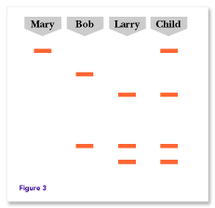](http://www.google.com.au/url?sa=i&rct=j&q=dna%20testing%20for%20paternity&source=images&cd=&cad=rja&docid=sBEetW_KdrC23M&tbnid=OPeSTOy4R7AAsM:&ved=0CAUQjRw&url=http://genetics.thetech.org/ask/ask20&ei=pU0yUu2OI4fjkgWq6ICAAQ&psig=AFQjCNGkZTLnvQAogUUqN-zvEhwREsxaSg&ust=1379114784831978)

* 1. Bob is the father of the child.
  2. Larry is the father of the child.
  3. Neither Bob or Larry are the father.
  4. Mary just isn’t that “kind of Girl”.

More questions on next page.

The following 3 questions refer to the diagram of the cell membrane shown below.



12. In the diagram above the hydrophilic structure is

a..A.

b. B

c. C

d. D

13. structures A and B form molecules called:

a. Phospates

b. Lipids

c. Proteins

d. Phopho-lipids.

14. Alcohols and steroids are able to move through:

a. Structure A

b. Structure B

c. Structures C and D

d. Alcohols and steroids are never able to pass through the membrane.

15. **Use the diagram below to answer the question that follows.**

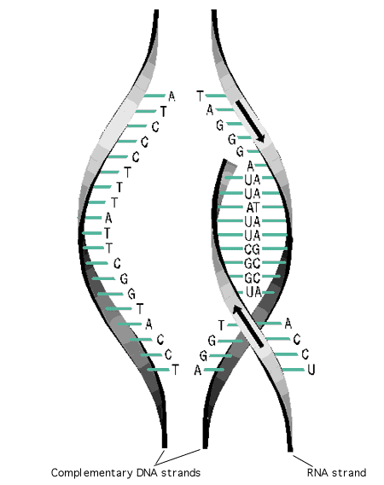

This diagram shows the process of:

1. RNA Translocation.
2. DNA Translocation.
3. DNA Transcription.
4. DNA Translation.

16. One technique that has automated and sped up DNA profiling is:

a. The use of higher voltage gels.

b. Dye (often fluorescent).

c. The use of ligase enzymes.

d. The use of proteins sequence analysis.

17. The gene causing a hereditary disease can be found using:

a. DNA profiling and genetic probes.

b. DNA polymerization.

c. Transgenics.

d. Protein amimo acid sequencing.

18. The tRNA anti-codon for the amino acidThreonine is **ACU**. From this we can find the DNA triplet and the mRNA codon for Threonine. Which of the following is correct?

|  |  |
| --- | --- |
|  | **mRNA codon** |
| A | UTC |
| B | UGA |
| C | UTA |
| D | TTA |

19. When the hormone cortisol reaches a target cell, it enters the cell through the phospholipid bilayer. It then combines with a receptor protein inside the cell. The combined substance enters the nucleus, where it activates genes to produce a protein.

Cortisol is a

a. water soluble amine.

b. water soluble steroid.

c. water soluble amine.

d. lipid soluble steroid.

20. Which of the following statements relating to the Human Genome Project is true?

(a) The DNA sequencing is yet to be completed.

(b) Information from the project is freely available to all scientists.

(c) It can provide cures for all human diseases.

(d) It cannot provide new avenues for advances in medicine.

End of Multiple Choice Section

**Short Answer Questions**

1. List 3 potential benefits of the Human Genome Project.

(3 marks)

______________________________________________________________________________________________________________________________________________________________________________________________________________________________________________________________________________________________________________________

1. The following is a sequence of nitrogen bases found in part of a human cell.

AUGGCCUCGAUAACGGCCACCAUG

(i) What type of substance do these bases belong to? (1 mark)

(ii) Give two reasons for your answer.

(2 mark)

______________________________________________________________

(iii) How many amino acids could this piece code for? (1 mark)

1. How are the component molecule of proteins aligned in the correct order during translation in protein synthesis?

(3 marks)

__________________________________________________________________________________________________________________________________________________________________________________________________________________________________________________________________________________________________________________________________________________________________________________________________________________________________________________

4. List 4 functions of the plasma membrane.

(4 marks)

_______________________________________________________________________________________________________________________________________________________________________________________________________________________________________________________________________________________________________________________________________________

5. A human white blood cell engulfs a bacterial cell. Name and explain the process the white blood cell would use to do this.

(4 marks)

_______________________________________________________________________________________________________________________________________________________________________________________________________________________________________________________________________________________________________________________________________________

6 . The cell membrane regulates the transport of materials into and out of the cell. One such process is carrier mediated active transport.

Explain how carrier mediated active transport occurs.

(7 marks)

_______________________________________________________________________________________________________________________________________________________________________________________________________________________________________________________________________________________________________________________________________________

7. a. What does PCR stand for and what is it used for?

(2 marks)

_______________________________________________________________________________________________________________________________________________________________________________________________________________________________________________________________________________________________________________________________________________

1. List the steps involved in the PCR process.

(7 marks)

___________________________________________________________________________________________________________________________________________________________________________________________________________________________________________________________________________________________________________________________________________________________________________________________________________________________________________________________________________________________________________________________________________________________________________________________________________________________________________________________________________________________________________________________________________________________________________________________________________________________________________________________________________________________________________________________________________________________________________________________________________________________________________________________________________________________________________________________________________________________________________________________________________________________________________________________________________________________________________________________________________________________________________________________________________________________________________________________________________________________________________________________________________________________________________________________________________________________________________________________________________________________________________________________________________

**END OF TEST**